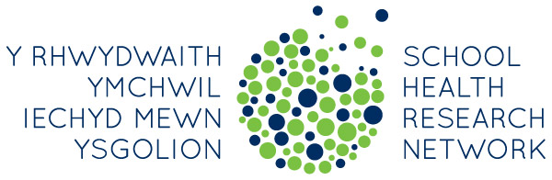
Summer Event 2018
Digwyddiad yr Haf 2018
Parc Y Scarlets – 12/06/2018
09.30 | Registration/Coffee  Cofrestru / Coffi
10.00 | Welcome and introduction  Croeso a chyflwyniad  Joan Roberts
10.05 | Student Survey and School Environment Questionnaire: Your Feedback  Adborth o’r arolwg a’r holiadur amgylchedd yr ysgol: Eich adborth  Dr Gillian Hewitt
10.45 | SHRN and the Health and Education Context in Wales  Y Rhwydwaith Ymchwil Iechyd Mewn Ysgolion a’r Cyd-destun Iechyd ac Addysg yng Nghymru  Sarah Andrews: Head of Programme – Healthy Settings / Pennaeth Rhaglen – Lleoliadau Iach
11.15 | BREAK  EGWYL
11.30 | Update on the Health and Wellbeing AoLE: Opportunity for Discussion  Diweddariad ar y maes dysgu a phrofiad iechyd a lles: Cyfle i drafod  Cressy Morgan: Consortia Lead / Arwain Consortiwm
12.15 | School Presentations  Cyflwyniadau gan ysgolion  Claire Samuel, Ysgol Olchfa, Swansea  Rachel Edwards, Pembroke School, Pembrokeshire  Vanesssa Jenkins, Ysgol Maesydderwen, Powys
13.00 | LUNCH  CINIO
13.30 | Group Work Around the Use and Potential Use of Student Health and Wellbeing Reports in Schools  Gwaith grŵp ynghylch defnyddio a’r defnydd posibl o adroddiadau iechyd a lles myfyrwyr mewn ysgolion  Joan Roberts
14.20 | Public Health Leadership and Action in Schools  Arweinyddiaeth a Chamau Gweithredu Iechyd Cyhoeddus mewn Ysgolion  DR Gillian Hewitt
14.50 | Evaluation and Close  Gwerthuso a diwedd

