How to change your school’s intranet password

- Go to SHRN.org.uk and log in to the intranet

- Once you have logged in, hover your mouse at the top of the page until a black line appears

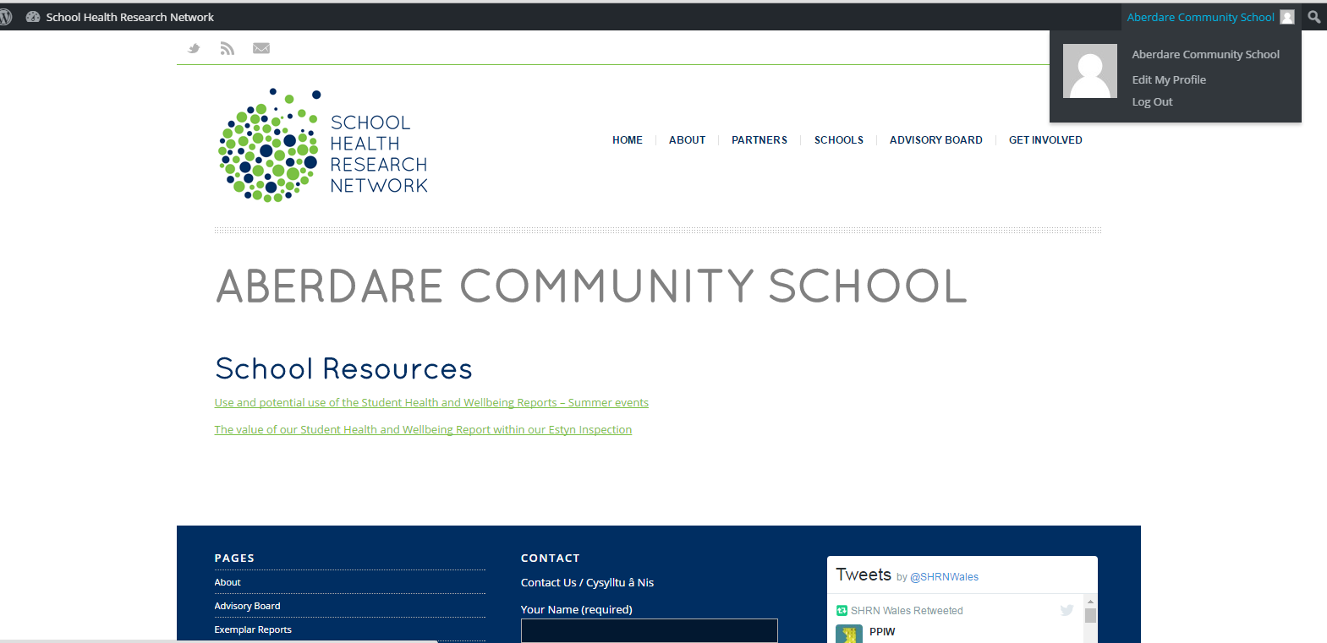

- Click on Edit My Profile
- You will see this screen…
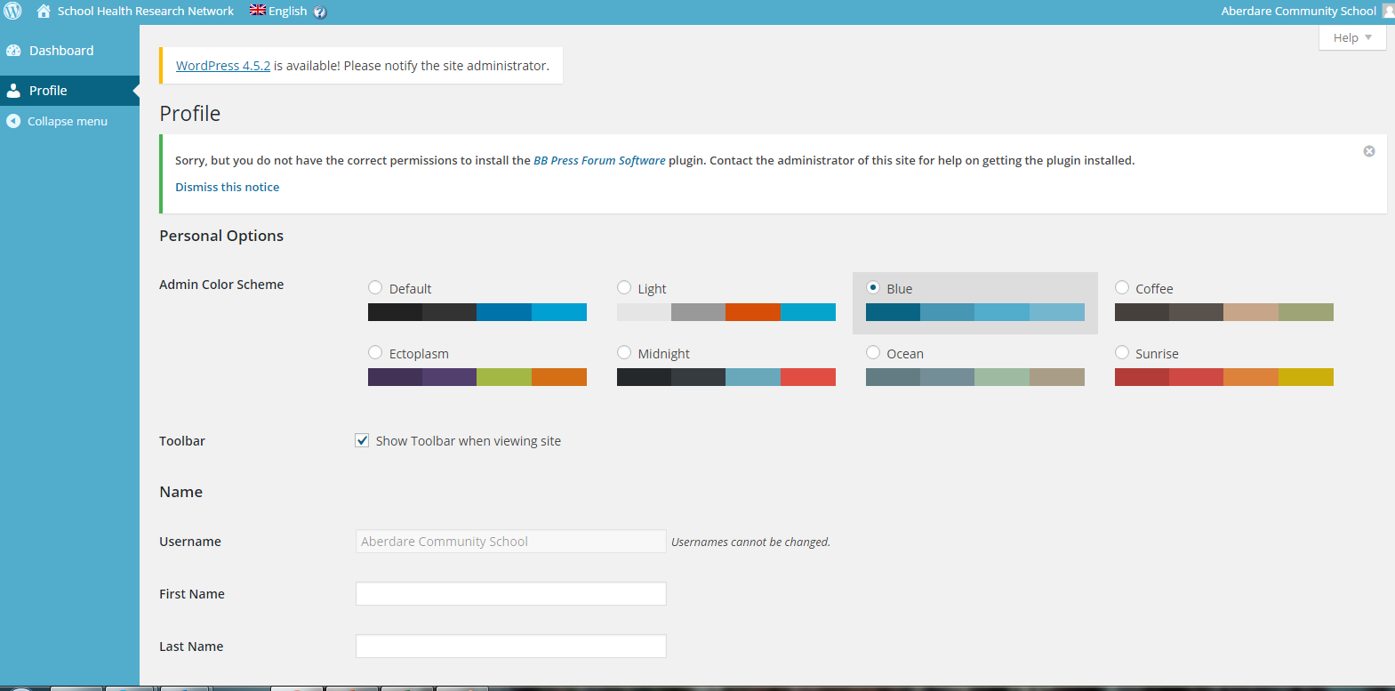

- Scroll down until you see the option to generate a new password. Your current password will be in the box, replace this with the password of your choosing
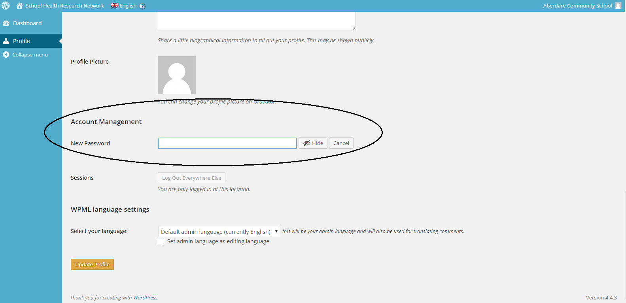

- Click Update Profile

