**PHW webinar recording**

As you will know, we were unfortunately unable to hold our usual summer networking event in 2022.

However, SHRN and Public Health Wales hosted a joint virtual webinar in lieu of this. The webinar focussed on the whole school approach to emotional and mental wellbeing in order to help schools as they begin to implement and embed the framework. The webinar contains several presentations and includes an introduction to the new SHRN Network Manager – Maria Boffey.

If you are interested in watching the webinar, you can find a link to the recording below:

[https://www.youtube.com/watch?v=_C1jFjUd9o8](https://eur02.safelinks.protection.outlook.com/?url=https%3A%2F%2Fwww.youtube.com%2Fwatch%3Fv%3D_C1jFjUd9o8&data=05%7C01%7Cclarkel124%40hwbcymru.net%7C1e6b0eaa07714f9ed1f708dabc1d381e%7C4f3f0e52b734416494091b601d147993%7C0%7C0%7C638029131086973272%7CUnknown%7CTWFpbGZsb3d8eyJWIjoiMC4wLjAwMDAiLCJQIjoiV2luMzIiLCJBTiI6Ik1haWwiLCJXVCI6Mn0%3D%7C3000%7C%7C%7C&sdata=0%2BOhgzmxZgD7Hn1m84d4agoEAxXitvEtStl2q1GjqRM%3D&reserved=0)

**Upcoming Webinars**

We have several other webinars scheduled in the coming months. You can find information on these below:

* End of Feb: Nick Page and Rebecca Anthony flavoured cigarettes and online communication/cyber bullying (need to finalise title and date before sending)
* Mid-March: Graham Moore and Rachel Brown vaping (need to finalise title and date before sending)
* May?: Rebecca Anthony trends in mood symptoms (need to finalise title and date before sending)
* July: Sara Long - Curriculum for Wales: School case studies of the aims, goals and new school practices from the perspectives of a range of school staff across Wales (need to finalise date before sending)

**Primary SHRN Health and Wellbeing Survey: Help with promoting to your feeder schools.**

Mainstream primary schools from across Wales have been invited to take part in our KS2 Student Health and Well-being Survey between **30th November 2022 and 31st March 2023.**

The SHRN team delivered the Primary SHRN Health and Wellbeing Teacher Information Webinar on Thursday 19th January 2023, giving insight into What SHRN is, its expansion into primary schools, its benefits and how to get involved to primary schools and other interested colleagues. It also featured a presentation from the Director of Learning for Health, Wellbeing, House and PSHE at Ysgol Aberconwy, Rhydian Jones, who presented on how SHRN data has changed the wellbeing landscape at his school.

We would be grateful for your support in promoting this survey to your feeder schools and other interested colleagues by forwarding on the [Primary SHRN Health and Wellbeing Teacher Information Webinar recording](https://www.youtube.com/watch?v=kRdBFPEJy9U&ab) and [slides](https://www.shrn.org.uk/wp-content/uploads/2023/01/2023.01.19-Primary-SHRN-Health-and-Wellbeing-Survey-Information-Webinar-Slides.docx.pdf) and [study invitation](https://www.shrn.org.uk/wp-content/uploads/2022/12/1-School-Invite-Letter_-v0-031122-SO.pdf).

If you or your colleagues would like to get in touch about the expansion of the network into primary schools please contact the SHRN Network Manager supporting the expansion, Rosie Mellors.

* Sara Rees NCMH National Centre for Mental Health young person advisory group recruitment – Do you have text for this? I can’t find any?
* PHW observatory dashboard (needs text)
* Rosie introduction (need text from Rosie)

**Introducing Rosie Mellors, SHRN Network Manager**

**Call for parents/carers– do we want text with this or just the image?**

* Call for schools for Rosie’s parent panel work (needs text)

**Allwch chi helpu gyda'r astudiaeth 'Cymorth digidol i bobl ifanc gyda'u hwyliau a'u lles'?**

Mae ymchwilwyr ym Mhrifysgol Caerdydd wedi datblygu rhaglen/ap dwyieithog gyda phobl ifanc i gefnogi eu hwyliau a'u lles, o'r enw **HwbHwyliau**. Ydych chi'n gwybod am unrhyw bobl ifanc a fyddai â diddordeb mewn treialu'r rhaglen? Efallai yr hoffech roi gwybod i arweinydd lles yr ysgol am y prosiect.

**Mae'n gyfle i gynnig cymorth iechyd meddwl i bobl ifanc, a bydd yr adborth yn ein helpu i ddatblygu adnoddau yn y dyfodol. Mae pawb sy'n cymryd rhan yn derbyn tocyn rhodd a thystysgrif. Mae'n rhad ac am ddim i gymryd rhan.**

**Mae staff neu rhieni/gofalwyr yn gallu annog pobl ifanc (13-19 oed) sydd yn profi hwyliau isel (neu broblemau eraill gyda'u hwyliau a'u) - i fynd i'r wefan uchod am fwy o wybodaeth ac i lenwi ffurflen gymryd rhan:** [**https://cymraeg.ncmh.info/help-with-research/digital-support-study/**](https://cymraeg.ncmh.info/help-with-research/digital-support-study/)

Mae **fideo ar y prosiect** ar y wefan hon, neu gallwch ei weld yma:

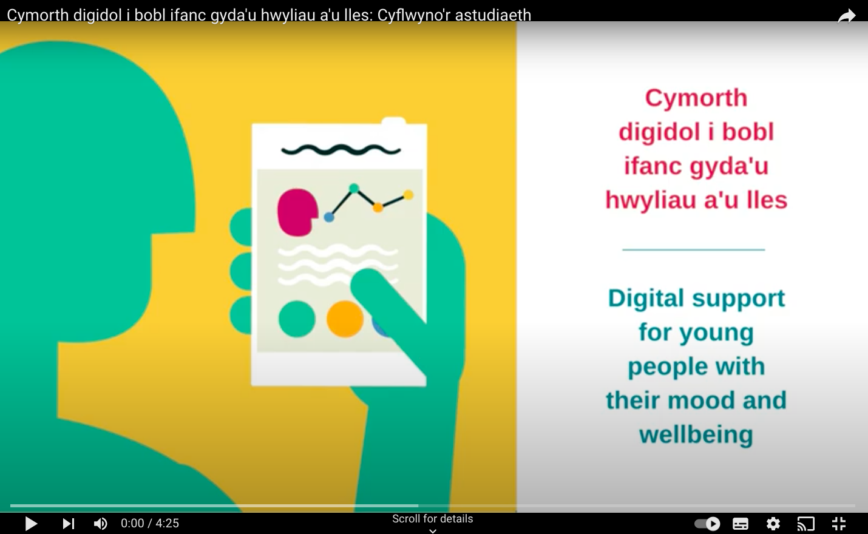

Gall y tîm ymchwil hefyd anfon **cardiau post** am yr astudiaeth i'r ysgol y gellir eu rhoi i bobl ifanc. Gall rhieni a gofalwyr hefyd gymryd rhan, ac efallai yr hoffech chi hefyd rannu manylion y prosiect yn eich gohebiaeth ar-lein neu gylchlythyrau gyda rhieni/gwarcheidwaid.

Mae Dr Rhys Bevan Jones (seiciatrydd ac arweinydd yr astudiaeth) hefyd yn hapus i gyflwyno sesiwn ar-lein ar y prosiect, iechyd meddwl a gyrfaoedd (e.e. ar feddygaeth, seicoleg a chelf) i fyfyrwyr yn eich ysgol. Yn ddiweddar enillodd Rhys 'Wobr Arloesedd Digidol' gan y Gymdeithas Iechyd Meddwl Plant a'r Glasoed (ACAMH) am ei waith ar ddatblygu rhaglenni iechyd meddwl digidol.

Am ragor o wybodaeth, ewch i wefan yr astudiaeth neu e-bostiwch: [YmchwilPoblIfancArlein@caerdydd.ac.uk](mailto:YmchwilPoblIfancArlein@caerdydd.ac.uk)