**PHW webinar recording**

As you will know, we were unfortunately unable to hold our usual summer networking event in 2022.

However, SHRN and Public Health Wales hosted a joint virtual webinar in lieu of this. The webinar focussed on the whole school approach to emotional and mental wellbeing in order to help schools as they begin to implement and embed the framework. The webinar contains several presentations and includes an introduction to the new SHRN Network Manager – Maria Boffey.

If you are interested in watching the webinar, you can find a link to the recording below:

[https://www.youtube.com/watch?v=_C1jFjUd9o8](https://eur02.safelinks.protection.outlook.com/?url=https%3A%2F%2Fwww.youtube.com%2Fwatch%3Fv%3D_C1jFjUd9o8&data=05%7C01%7Cclarkel124%40hwbcymru.net%7C1e6b0eaa07714f9ed1f708dabc1d381e%7C4f3f0e52b734416494091b601d147993%7C0%7C0%7C638029131086973272%7CUnknown%7CTWFpbGZsb3d8eyJWIjoiMC4wLjAwMDAiLCJQIjoiV2luMzIiLCJBTiI6Ik1haWwiLCJXVCI6Mn0%3D%7C3000%7C%7C%7C&sdata=0%2BOhgzmxZgD7Hn1m84d4agoEAxXitvEtStl2q1GjqRM%3D&reserved=0)

**Upcoming Webinars**

We have several other webinars scheduled in the coming months. You can find information on these below:

* 20/4/23: Nick Page and Rebecca Anthony Menthol cigarette use by young smokers in Wales prior to the flavour ban / Association between online communications and mental wellbeing
* 7/3/23: Graham Moore and Rachel Brown: E-cigarette use, and smoking, among young people in Wales / Young people's perceptions of use and availability of e-cigarettes
* Mid-May (date to be finalised): Rebecca Anthony trends in mood symptoms
* July or September: Sara Long - Curriculum for Wales: School case studies of the aims, goals and new school practices from the perspectives of a range of school staff across Wales

**Primary SHRN Health and Wellbeing Survey: Help with promoting to your feeder schools.**

Mainstream primary schools from across Wales have been invited to take part in our KS2 Student Health and Well-being Survey between **30th November 2022 and 31st March 2023.**

The SHRN team delivered the Primary SHRN Health and Wellbeing Teacher Information Webinar on Thursday 19th January 2023, giving insight into What SHRN is, its expansion into primary schools, its benefits and how to get involved to primary schools and other interested colleagues. It also featured a presentation from the Director of Learning for Health, Wellbeing, House and PSHE at Ysgol Aberconwy, Rhydian Jones, who presented on how SHRN data has changed the wellbeing landscape at his school.

We would be grateful for your support in promoting this survey to your feeder schools and other interested colleagues by forwarding on the [Primary SHRN Health and Wellbeing Teacher Information Webinar recording](https://www.youtube.com/watch?v=kRdBFPEJy9U&ab) and [slides](https://www.shrn.org.uk/wp-content/uploads/2023/01/2023.01.19-Primary-SHRN-Health-and-Wellbeing-Survey-Information-Webinar-Slides.docx.pdf) and [study invitation](https://www.shrn.org.uk/wp-content/uploads/2022/12/1-School-Invite-Letter_-v0-031122-SO.pdf).

If you or your colleagues would like to get in touch about the expansion of the network into primary schools please contact the SHRN Network Manager supporting the expansion - [Rosie Mellors](mailto:mellorsr@cardiff.ac.uk).

* Introducing Rosie Mellors – Primary SHRN Network Manager

Rosie’s role is to drive the expansion of the network, which is well-established in Secondary Schools across Wales, into Primary Schools. She provides support to the team and stakeholders in this context, and in the areas of pupil and parent engagement.

Rosie has spent her career working in charities and higher education institutions leading initiatives which promote inclusivity and intentional spaces for learning across STEM and humanities. Most proudly, Rosie coordinated, project managed and directed the award-winning Physics Mentoring Project since its conception in 2018, developing the confidence and self-efficacy university students and school learners across Wales, successfully changing attitudes toward Physics A levels and influencing Welsh Government STEM education policy: [https://physicsmentoring.co.uk/](https://eur03.safelinks.protection.outlook.com/?url=https%3A%2F%2Fphysicsmentoring.co.uk%2F&data=05%7C01%7CDaviesM82%40cardiff.ac.uk%7C215e18bae7f547296db708db007fb492%7Cbdb74b3095684856bdbf06759778fcbc%7C1%7C0%7C638104320699390890%7CUnknown%7CTWFpbGZsb3d8eyJWIjoiMC4wLjAwMDAiLCJQIjoiV2luMzIiLCJBTiI6Ik1haWwiLCJXVCI6Mn0%3D%7C3000%7C%7C%7C&sdata=iBhEJX2m7ERpzn0DhfqUG633EhmBfUF03geQcGyUYbE%3D&reserved=0)

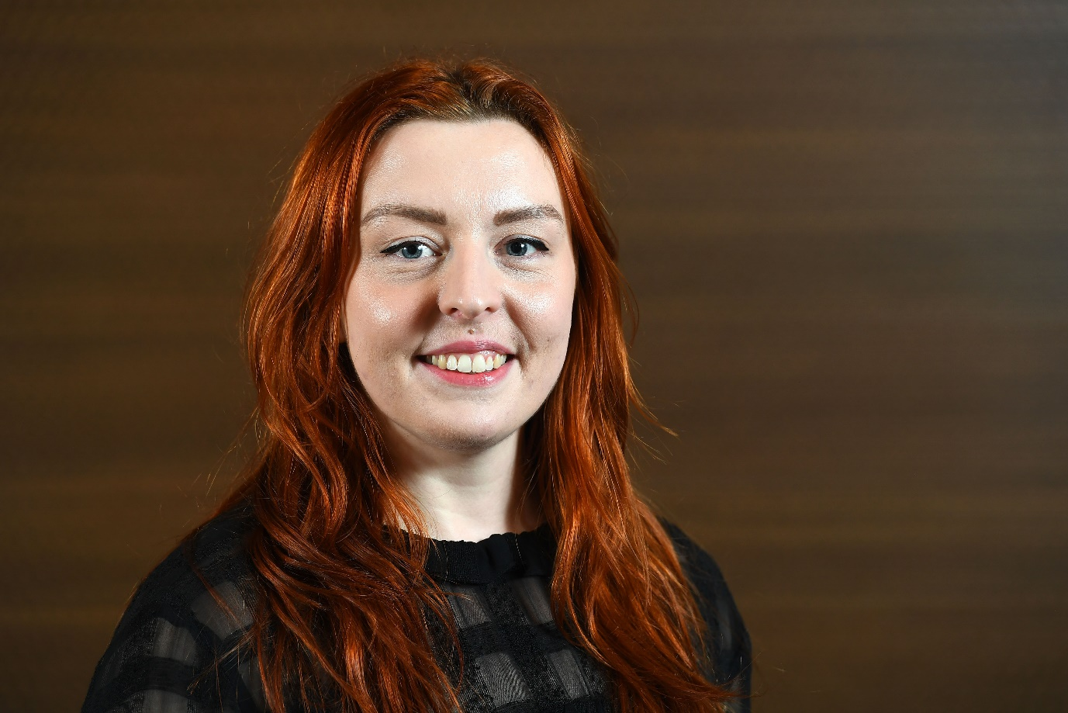

**Save a spot in your diary: Summer Events**

Dates:

South/East Wales – Radisson Blu Cardiff (include address) – 12/6/23

West Wales – Parc Y Scarlets (add address) – 20/6/23

North Wales – Quay hotel and Spa (add address) – 28/6/23

* Sara Rees NCMH National Centre for Mental Health young person advisory group recruitment – Do you have text for this? I can’t find any?

Calling all young people!  
  
Are you aged between 14-25 years, and have lived experience of mental ill health and/or neurodiverse conditions?

We’re looking for new voices to join our Young People’s Advisory Group (YAG).

The National Centre for Mental Health is working to learn more about what causes mental health conditions, from our environment and life experiences to our genetics and biological makeup. By understanding the causes, we can work to develop better diagnosis, treatment and support for the future.

Our YAG allows young people to shape mental health research through having their say.

What’s involved?

* A chance to have your voice listened to in a supportive community
* An opportunity to use your experience to help others and affect positive change
* Access to training
* A chance to boost your CV through public mental health involvement

Interested?

Email Sarah: reessj2@cardiff.ac.uk

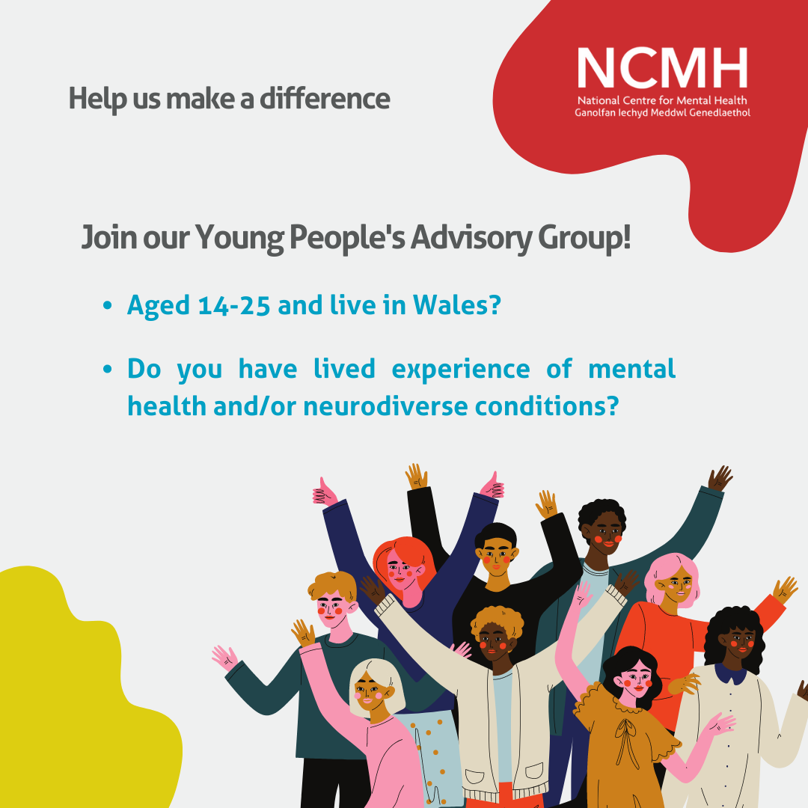

**Can you help with the 'Digital support for young people with their mood & wellbeing' study?**

Researchers at Cardiff University have developed a bilingual program/app with young people to support their mood and well-being, called **MoodHwb.**Do you know of any young people who would be interested in trialling the programme? You might wish to inform the school's wellbeing lead about the project.

**It is an opportunity to offer mental health support to young people, and the feedback will help to develop resources in the future. All participants will receive a gift voucher and certificate. It's free to take part.**

**Staff or parents/carers can encourage young people (13-19 years old) who are experiencing low mood (or other difficulties with their mood/wellbeing) to go to the study website for more information and to fill in a participation form:**[**https://www.ncmh.info/help-with-research/digital-support-study/**](https://eur03.safelinks.protection.outlook.com/?url=https%3A%2F%2Fwww.ncmh.info%2Fhelp-with-research%2Fdigital-support-study%2F&data=05%7C01%7CBevanJonesR1%40cardiff.ac.uk%7Cd090eefcb06946b94ed908dafad65d1c%7Cbdb74b3095684856bdbf06759778fcbc%7C1%7C0%7C638098095829383666%7CUnknown%7CTWFpbGZsb3d8eyJWIjoiMC4wLjAwMDAiLCJQIjoiV2luMzIiLCJBTiI6Ik1haWwiLCJXVCI6Mn0%3D%7C3000%7C%7C%7C&sdata=t8KnJ7vyxvcy2LcMsp2gEuDHlSGUTwEFatU%2BujBiJ9s%3D&reserved=0)

There is a video on the project on this site, or you can access it by **clicking on the image below:**

[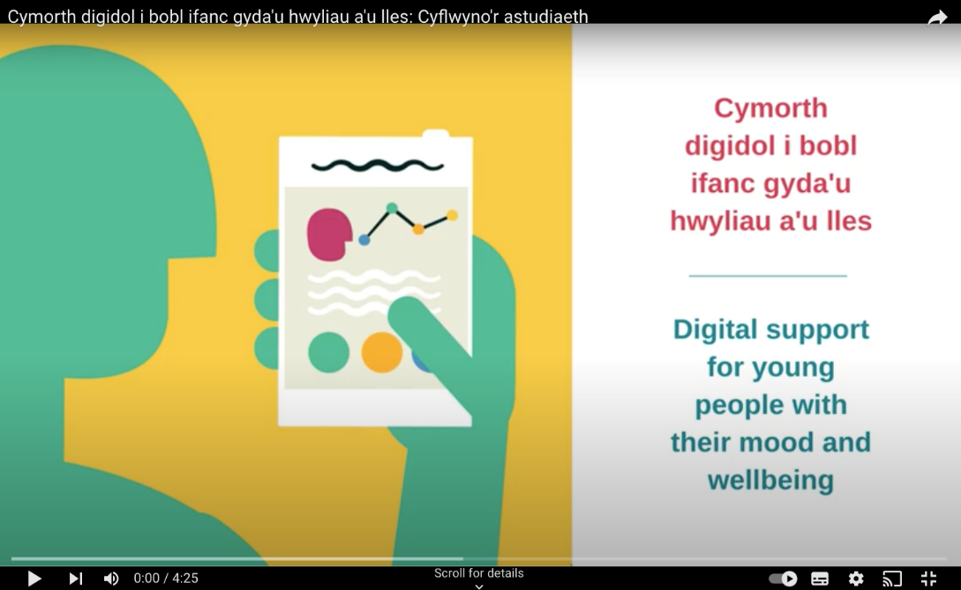](https://eur03.safelinks.protection.outlook.com/?url=https%3A%2F%2Fwww.youtube.com%2Fwatch%3Fv%3DdZSr3qkyzmE%26t%3D9s&data=05%7C01%7CBevanJonesR1%40cardiff.ac.uk%7Cd090eefcb06946b94ed908dafad65d1c%7Cbdb74b3095684856bdbf06759778fcbc%7C1%7C0%7C638098095829383666%7CUnknown%7CTWFpbGZsb3d8eyJWIjoiMC4wLjAwMDAiLCJQIjoiV2luMzIiLCJBTiI6Ik1haWwiLCJXVCI6Mn0%3D%7C3000%7C%7C%7C&sdata=fywRc5B%2BRExuyogdRi5GUg7suZHgkzqlvsZKbxB%2F2rg%3D&reserved=0)

The research team can also send **postcards** about the study to the school which can be given to young people. Parents and carers can also take part, and you might also wish to share the project details in your online communication or newsletters with parents/guardians.

Dr Rhys Bevan Jones (psychiatrist and study lead) is also happy to present a virtual session on the project, mental health and careers (e.g. on medicine, psychology and art) for students at your school. Rhys recently won a 'Digital Innovation Award' by the Association for Child and Adolescent Mental Health (ACAMH) for his work on the development of digital mental health programmes.

For more info, please visit the study website or email: [YouthOnlineStudy@cardiff.ac.uk](mailto:YouthOnlineStudy@cardiff.ac.uk)