**Welcome to our SHRN newsletter for September 2023**

**Student Health and Wellbeing Survey 2023**

**Thank you to everyone for registering for the 2023 Student Health and Wellbeing Survey. You should by now have received the survey packs that we emailed to you on September 9th, and the live survey link from Ipsos emailed on September 14th. Please let us know if you haven’t received either of these, as they are essential for completing the survey successfully.**

**The survey opens for learners at 8am on Monday 18 September 2023, and you have until 3.30pm on Friday 22 December to finish surveying your pupils.**

**This year, we will also be running the SHRN** [School Environment Questionnaire (SEQ)](https://www.shrn.org.uk/school-environment-questionnaire-information/) **alongside the survey for the first time to enable schools to complete all SHRN activities during one ‘SHRN Term’.**

**The SEQ enables schools to look at how their wellbeing policies can affect the outcomes of their student survey. You can access it via an online link sent by Ipsos from 2 October to 22 December 2023. If you have any questions about this, please email** [shrn@cardiff.ac.uk](mailto:shrn@cardiff.ac.uk)

**Please don’t hesitate to get in touch about the survey if you have any questions or concerns and do pass our details on to parents and carers if they wish to contact us directly. We are here to help and support you, as are your Healthy School co-ordinators.**

**Shout About Success and celebrate your contribution to the SHRN community!**

If your school has benefitted from using SHRN data, and you are proud of the difference you have made to your learners’ health and wellbeing, our Network Manager, Maria Boffey would love to hear from you.

Case studies are a fantastic way of showcasing innovation and evidence-based practice, as well as sharing learning; exchanging ideas and helping colleagues share experiences. Maria would be delighted to hear from you and chat about how your story could inform and support our numerous projects and inform SHRN development and impact. Please email Maria at [boffeym1@cardiff.ac.uk](mailto:boffeym1@cardiff.ac.uk)

**SHRN Webinars**

Thank you to those of you who have attended our recent webinars. You can find recordings of the webinars below:

[***School-based interventions to prevent dating and relationship violence and gender-based violence (STOP DRV GBV).***](https://youtu.be/Yfhey45QIq8?list=PLnnr0B6i7Z7VS0uiBPOfJcf4kkdSywflD)This webinar was presented by Professor GJ Melendez-Torres, Exeter University.

[***Expanding SHRN into primary schools: National findings from the 2022/23 student health and wellbeing survey***](https://youtu.be/jxVpM1RMeWo?list=PLnnr0B6i7Z7VS0uiBPOfJcf4kkdSywflD)***.*** This webinar was presentedby Dr Kelly Morgan, Dr Caitlyn Donaldson and Amy Edwards, Cardiff University.

**Keeping School Data Safe: Information about Data Linkage**

An information video from the SAIL databank has been produced, detailing how data linkage works. This recording is informative for schools taking part in the Student Health and Wellbeing Survey and would like to know about how the data is stripped of any identifiable information, encrypted, and linked with other data ready for researchers to use.

To view this recording please click [here](https://vimeo.com/476297862).

**DECIPHer Parent and Carer Advisory Group**

[DECIPHer](https://decipher.uk.net/) (the home of SHRN) has launched its own Parent and Carer Advisory group for caring for children and young people under the age of 18 years old.

Dates for 2023 meetings and events can be found on our social media ([Twitter](https://twitter.com/ALPHA_DECIPHer) and [Instagram](https://www.instagram.com/alpha_decipher/) - @Alpha_Decipher). Please share with any parents, carers and other groups that may be interested in attending.

If you have any questions or require more information, please get in touch with Sophie Jones, Senior Public Involvement Officer: [joness206@cardiff.ac.uk](mailto:joness206@cardiff.ac.uk)

**Can you help with the 'Digital support for young people with their mood & wellbeing' study?**

Researchers at Cardiff University have developed a bilingual program/app with young people to support their mood and well-being, called **MoodHwb**. Do you know of any young people who would be interested in trialling the programme? You might wish to your school wellbeing lead about the project.

MoodHWB provides opportunities offer for mental health support to young people, and the feedback will help to develop resources in the future. All participants will receive a gift voucher and certificate. It's free to take part.

**Staff and parents/carers can encourage young people aged13-19 years old, who are experiencing low mood (or other difficulties with their mood/wellbeing,) to go to the study website for more information and complete a participation form:** <https://www.ncmh.info/help-with-research/digital-support-study/>

The research team can also send **postcards** about the study to the school which can be given to young people. Parents and carers can also take part, and you might also wish to share the project details in your online communication or newsletters with parents/guardians.

Dr. Rhys Bevan Jones (psychiatrist and study lead) is also happy to present a free virtual session on the project and present alongside information about mental health and careers (medicine, psychology, and art for example) for students at your school. Rhys recently won a ['Digital Innovation Award'](https://www.acamh.org/blog/acamh-awards-2022-results/) by the Association for Child and Adolescent Mental Health (ACAMH) for his work on the development of digital mental health programmes.

For more info, please visit the study website or email: [YouthOnlineStudy@cardiff.ac.uk](mailto:YouthOnlineStudy@cardiff.ac.uk)

Find out more by watching a video on the project on this site, or you can access it by **clicking on the image below:**

[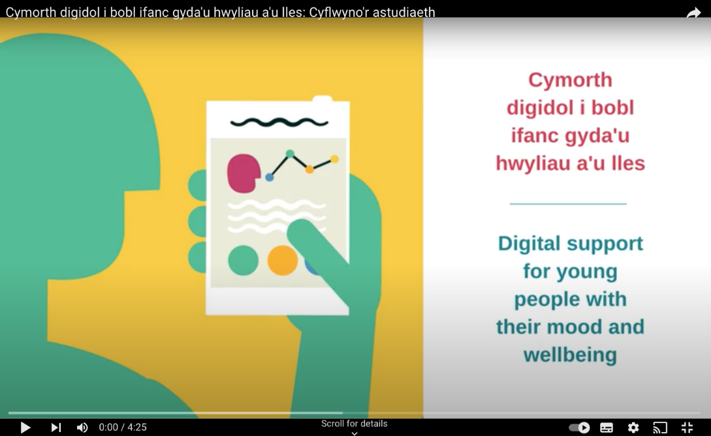](https://eur03.safelinks.protection.outlook.com/?url=https%3A%2F%2Fwww.youtube.com%2Fwatch%3Fv%3DdZSr3qkyzmE%26t%3D9s&data=05%7C01%7CBevanJonesR1%40cardiff.ac.uk%7Cd090eefcb06946b94ed908dafad65d1c%7Cbdb74b3095684856bdbf06759778fcbc%7C1%7C0%7C638098095829383666%7CUnknown%7CTWFpbGZsb3d8eyJWIjoiMC4wLjAwMDAiLCJQIjoiV2luMzIiLCJBTiI6Ik1haWwiLCJXVCI6Mn0%3D%7C3000%7C%7C%7C&sdata=fywRc5B%2BRExuyogdRi5GUg7suZHgkzqlvsZKbxB%2F2rg%3D&reserved=0)